ClassDemo

Adam Cummings

3/18/2021

## R Markdown

This is an R Markdown document. Markdown is a simple formatting syntax for authoring HTML, PDF, and MS Word documents. For more details on using R Markdown see <http://rmarkdown.rstudio.com>.

When you click the **Knit** button a document will be generated that includes both content as well as the output of any embedded R code chunks within the document. You can embed an R code chunk like this:

summary(cars)

## speed dist   
## Min. : 4.0 Min. : 2.00   
## 1st Qu.:12.0 1st Qu.: 26.00   
## Median :15.0 Median : 36.00   
## Mean :15.4 Mean : 42.98   
## 3rd Qu.:19.0 3rd Qu.: 56.00   
## Max. :25.0 Max. :120.00

str(cars)

## 'data.frame': 50 obs. of 2 variables:  
## $ speed: num 4 4 7 7 8 9 10 10 10 11 ...  
## $ dist : num 2 10 4 22 16 10 18 26 34 17 ...

head(cars)

## speed dist  
## 1 4 2  
## 2 4 10  
## 3 7 4  
## 4 7 22  
## 5 8 16  
## 6 9 10

## Including Plots

You can also embed plots, for example:

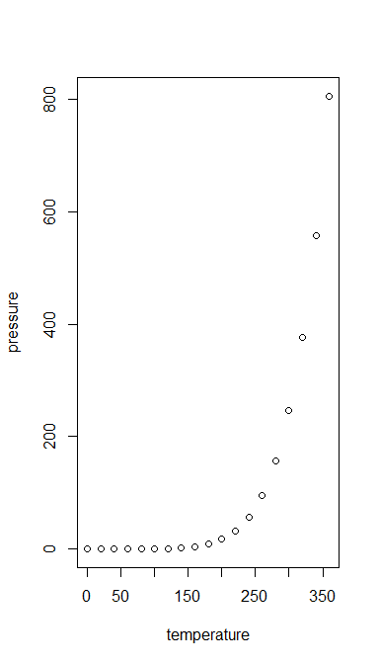

Note that the echo = FALSE parameter was added to the code chunk to prevent printing of the R code that generated the plot.

